Online Bidding System

Team members: Mounica Mannam,Pavan Kumar Madavaram,Caleb Cheriyout

Overview

The project Online Bidding System is the software developed to simplify the communication process between the Seller and the Buyer. The software operators include the admin, the Seller, and the Buyers. The seller is responsible for selling a product in the site where other people can buy it based on their winning in the auction. This information is stored in the database along with their details. The admin can view Customer and Seller details and Auction details Auction winning report, Product details. When a person placed a bid on a particular product then he is eligible to place an order for the product when he wins the auction by the end of the date where auction closes. The system can thus reduce complexity in maintaining Bidding details and ease the process of Auction for a Product. The project is developed on ASP .Net platform and supported by a SQL database to store the user specific details.

To develop an online auction system which will provide a forum for sellers to meet and interact with buyers, and sell items to interested bidders.

* This auction website works online. The bidder and seller can participate in auction from anywhere at any time through online auction.
* Those who wish to take part in bidding or sell products at the site have to register at the site as customer. Only authenticated customers can take part in selling or in bidding.
* Customer can see the profile of the bidding history of items which are still open.

Similarly, the seller can see the progress of bidding.

* This will store bidders record and bidding record.

This application is powered by API which enables to implement it with any frontend design.

Tools used

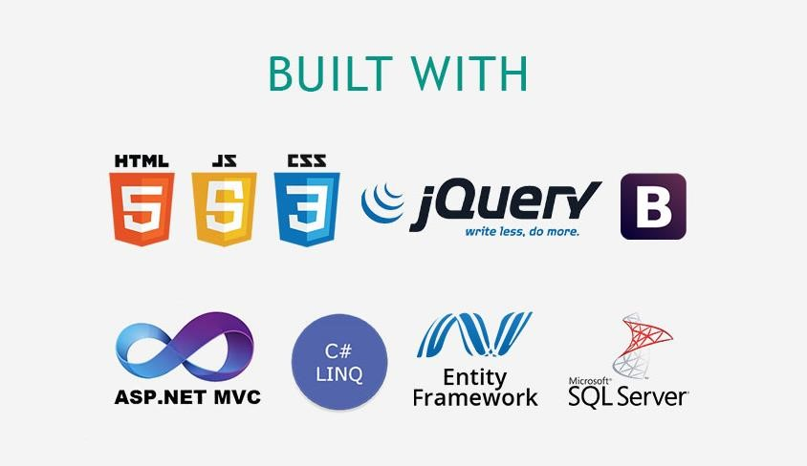

Languages used

C sharp: : C# is a modern, type safe programming language, object-oriented language that enables programmers to quickly and easily build solutions for the Microsoft .NET platform.

HTML: HTML is the standard markup language for documents designed to be displayed in a web browser. It can be assisted by technologies such as Cascading Style Sheets (CSS) and scripting languages such as JavaScript

JavaScript: JavaScript is a high-level, often just-in-time compiled language. It has application programming interfaces (APIs) for working with text, dates, regular expressions, standard data structures, and the Document Object Model (DOM).

Technologies Used:

## ASP.NET MVC:

## LINQ:

Entity Framework Core:

## Microsoft SQL Server:

**CSS**

**Ajax**

**lQuery**

**ER diagram:**

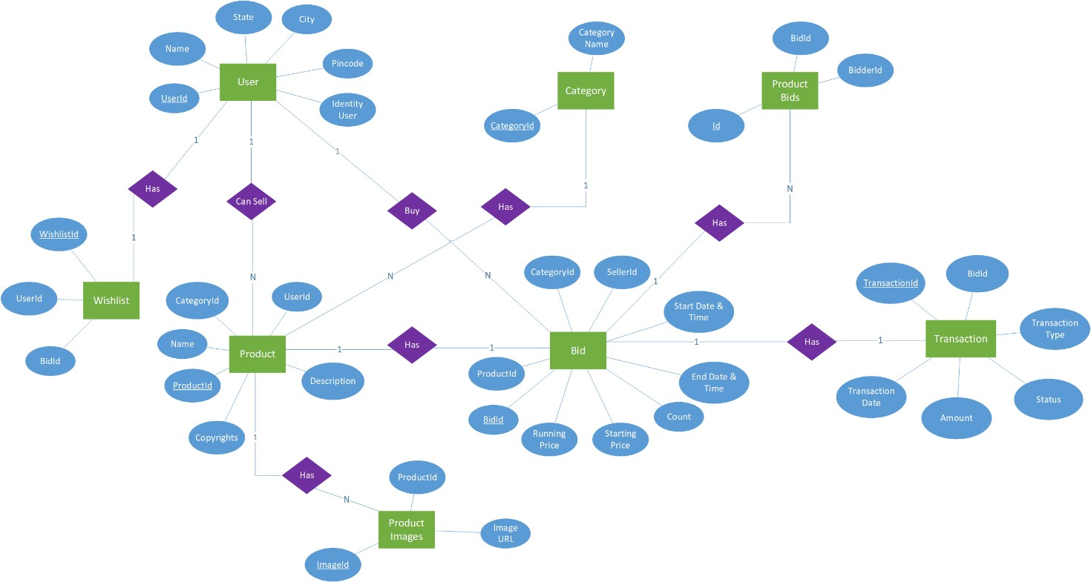

Project workflow

**Planning/Requirments Gathering 10 sept to 20sept**

**Desiging**

System design,use cases,crc cards,

activity diagram,ER diagram 21 sept to 29th sept

**Development**

Creating DataBase and connection 29th to 7thoct

Login / Registration Module oct 8th to 18th oct

Customer Module oct 19th to 30th oct

Product Module 1st nov to 10th nov

Report Module Nov 11tht to 20th nov

Dashboard nov 21st to 30 th nov

**Testing**

**If issues found correct them dec 1st to 9th dec**

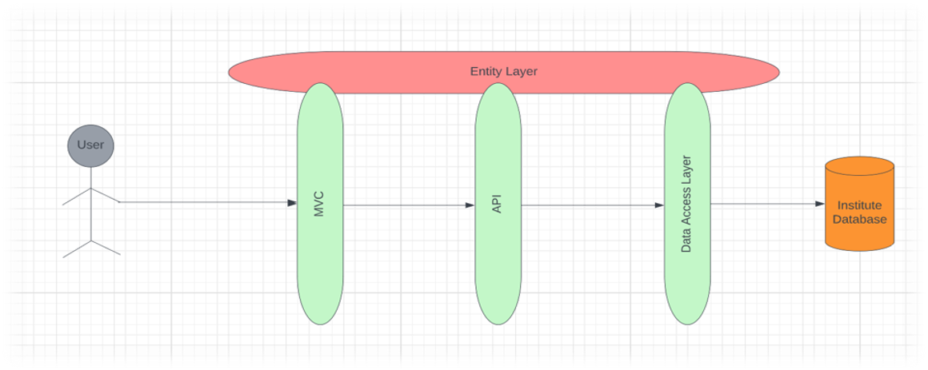

Microsoft Entity Framework Core helps in accomplishing database first approach or code first approach. For this project, database first approach is used. It creates dB Context which helps in interaction between Visual Studio and database.

## Models:

* The models represent the actual tables in the database mapped to the project by the Entity Framework are very important to work with the project.
* These models are classes in C# which are used to generate the actual database with the tables (models) when it comes to Code-First approach.

The following figure consists of all the models:

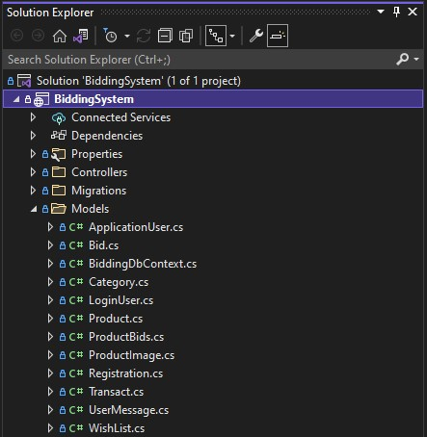

#### Fig 5.3 Models

**Models of the project:**

* ApplicationUser
* LoginUser
* Registration

##### 8.4.1 ApplicationUser

Application User model consists of id, email, password, phone number, first name, city, state, zip. This model includes complete details of users.

##### LoginUser

Login User model consists of details of users. Properties include email and password which are used to login to the website.

##### Registration

Registration model consists of details of new users. Properties include first name, email, phone number, state, city, zip and password.

API Controllers:

* APIController
* UserController

**8.5.1.1 APIController**

API controller consists of all the routes related to API. Contains the status of API.

UserController

User controller consists of all the routes related to Users. Includes all CRUD function calls of Users of the website.

FrontEnd Controllers:

##### HomeController

Home controller consists of all the views related to Homepage of the website. Includes homepage, error-404 page and server-500 page.

##### UserController

6

## Repositories:

* UserRepository